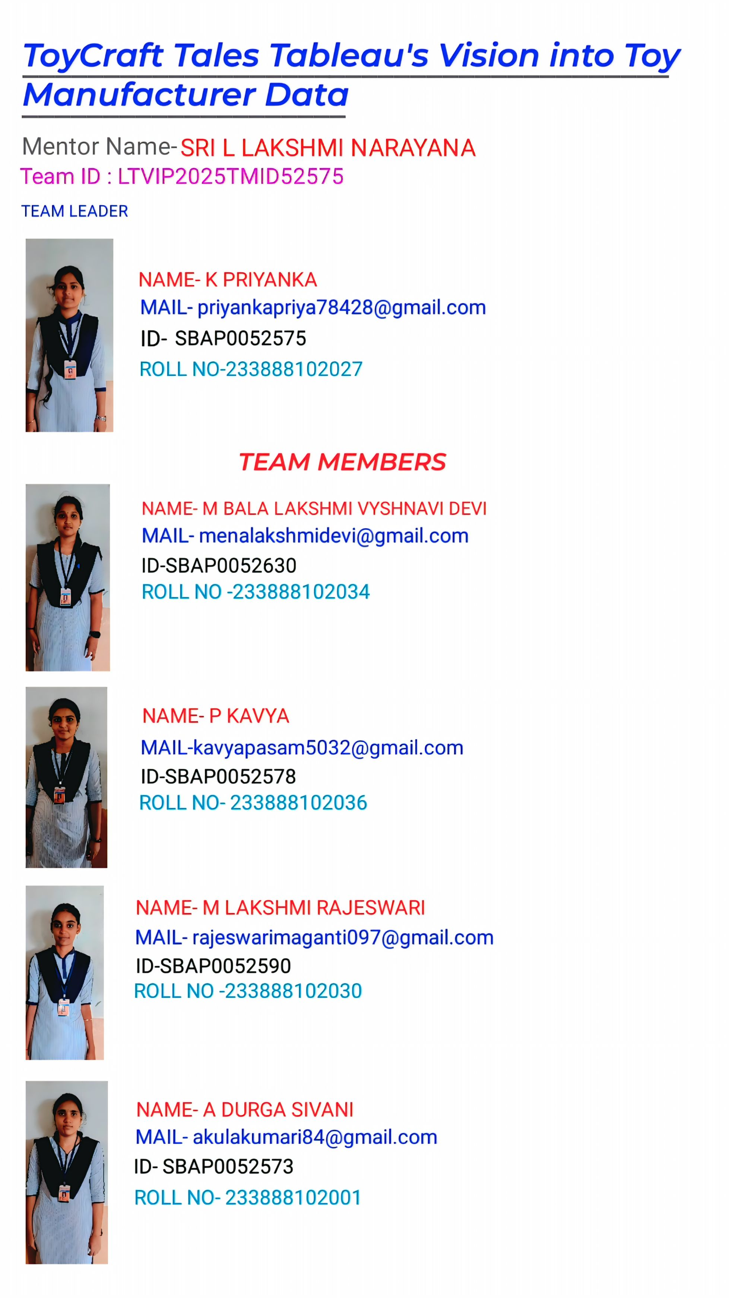

TEAM GROUP PHOTO



**ToyCraft Tales: Tableau's Vision into Toy Manufacturer Data**

strategic decisions and Production patterns, and consumer preferences. Craft interactive visualizations to guide Employ Tableau to delve into Toy Manufacturers' data, uncovering market trends, enhance market competitiveness  
The Toy Manufacturers' Data Exploration and Visualization Project aims to leverage the power of Tableau to provide a comprehensive analysis of the toy manufacturing industry. By delving into the vast dataset encompassing various facets of the industry, the project seeks to uncover valuable insights related to market trends, production patterns, and consumer preferences.Utilize Tableau to dissect market trends within the toy manufacturing sector. Explore historical sales data, identify emerging market demands, and highlight patterns that can inform strategic decisions. By visualizing market dynamics over time, the project aims to offer a deep understanding of the industry's evolution.Analyze consumer behavior and preferences by examining data related to popular toy categories, demographic trends, and purchasing patterns. Develop interactive visualizations that highlight consumer preferences, enabling manufacturers to align their product offerings with market demands. This insight is crucial for tailoring product development strategies to meet customer expectations.  
Scenario 1:  
Market Trend Analysis for Seasonal Products: The project could delve into historical sales data for different types of toys across various seasons and holidays. By visualizing the sales trends over the years, manufacturers can identify patterns in consumer preferences during specific times of the year. For instance, they might find that certain types of toys sell better during the holiday season, while others have higher demand during summer months. Armed with this insight, toy manufacturers can adjust their production schedules and marketing strategies accordingly to   
maximize sales and meet seasonal demands effectively.  
Scenario 2:  
  
Consumer Preference Analysis Across Demographics: Using demographic data such as age, gender, and location, the project could analyze consumer preferences for different types of toys. Interactive visualizations can be created to show how preferences vary among different demographic groups. For example, it might reveal that teenagers in urban areas have a higher preference for electronic toys, while younger children in rural areas prefer traditional toys such as dolls and action figures. This information can help manufacturers tailor their product offerings and marketing campaigns to target specific demographic segments more effectively.  
Scenario 3:

Product Performance Comparison Across Regions: By analyzing sales data across different regions or countries, the project could identify which toy categories perform better in certain geographic areas. For instance, it might find that educational toys are more popular in regions with a strong emphasis on education, while outdoor toys sell better in areas with favorable weather conditions. Visualizations could illustrate these regional differences in demand, allowing manufacturers to optimize their distribution channels and inventory management strategies to better serve each market.

**Project Flow**

To accomplish this, we have to complete all the activities listed below,

    Data Collection & Extraction from Database

o   Collect the dataset,

o    Storing Data in DB

o   Perform SQL Operations

o   Connect DB with Tableau   Data Preparation

o   Prepare the Data for Visualization

      Data Visualizations

o   Number of  Unique Visualizations

       Dashboard

o   Responsive and Design of Dashboard

     Story

o   No of Scenes of Story

    Performance Testing

o   Amount of Data Rendered to DB ‘

o   Utilization of Data Filters

o   No of Calculation Fields

o   No of Visualizations/ Graphs

    Web Integration

o   Dashboard and Story embed with UI With Flask

       Project Demonstration & Documentation

o   Record explanation Video for project end to end solution

o   Project Documentation-Step by step project development procedure

**Data Collection & Extraction from Database**

Data collection is the process of gathering and measuring information on variables of interest, in an established systematic fashion that enables one to answer stated research questions, test hypotheses, and evaluate outcomes and generate insights from the data

**Collect the dataset**

[**https://www.kaggle.com/datasets/thedevastator/toy-manufacturers-in-us-states?select=Week+39+-+US+Toy+Manufacturers+-+2005+to+2016.hyper**](https://www.kaggle.com/datasets/thedevastator/toy-manufacturers-in-us-states?select=Week+39+-+US+Toy+Manufacturers+-+2005+to+2016.hyper)



Toy Manufacturers in US States | Kaggle..

Toy Manufacturer Data by State and Year..

<https://www.kaggle.com/datasets/thedevastator/toy-manufacturers-in-us-states?select=Week+39+-+US+Toy+Manufacturers+-+2005+to+2016.hyper>

**understand the data**

Data contains all the meta information regarding the columns described in the CSV files. we have provided 1 CSV files:

1. Week 39 - US Toy Manufacturers - 2005 to 2016

Column Description for Week 39 - US Toy Manufacturers - 2005 to 2016

1. State: The state where the toy manufacturers are located. (Categorical)
2. Year: The year during which data was recorded. (Numeric)
3. Number of Manufacturers: The total number of toy manufacturers in a specific state and year. (Numeric)
4. Index: Number of toy manufacturer
5. Week 39 - US Toy Manufacturers - 2005 to 2016

### **Storing Data in DB & Perform SQL Operations**

Explanation video link:

<https://drive.google.com/file/d/1IT5zjFj39iHfANGY-K4LoCMd_t3Fp2cK/view?usp=sharing>

**Connect DB with Tableau**

Explanation video link:

<https://drive.google.com/file/d/1my-s-fRwF18ChA393xpS0EO_rZMrdASD/view?usp=sharing>

**Data Preparation**

Preparing the data for visualization involves cleaning the data to remove irrelevant or missing data, transforming the data into a format that can be easily visualized, exploring the data to identify patterns and trends, filtering the data to focus on specific subsets of data, preparing the data for visualization software, and ensuring the data is accurate and complete. This process helps to make the data easily understandable and ready for creating visualizations to gain insights into performance and efficiency.

Explanation video link 1: <https://drive.google.com/file/d/1my-s-fRwF18ChA393xpS0EO_rZMrdASD/view?usp=sharing>

**No of Unique Visualizations**

The number of unique visualizations that can be created with a given dataset. Some common types of visualizations that can be used to analyze the performance and efficiency of ToyCraft Tales: Tableau's Vision into Toy Manufacturer Data include bar charts, line charts, heat maps, scatter plots, pie charts, Maps, etc. These visualizations can be used to compare performance, track changes over time, show distribution, and relationships between variables, breakdown of revenue and customer demographics, workload, resource allocation, and location of hotels.

**Analysis on number of Manufacturer by Year**

Explanation video link: [Link](https://drive.google.com/file/d/1LGpw-F39KTSS4aV0kJuuOqxLJMcyAhDN/view?usp=sharing)

**Analysis on Toy Manufacturer by index**

Explanation video link:

[Link](https://drive.google.com/file/d/1H4j7gzuM3s4x5gsGS-upG7y3HcfkT4gw/view?usp=sharing)

**Analysis on toy Manufacturer in US state By Index**

Explanation video link: <https://drive.google.com/file/d/1g-6QhJDbE-UP3vdPI0vS6WF8yj9qMEOW/view?usp=sharing>

**Top 10 states toy manufacturer in US state**

Explanation video link:

[Link](https://drive.google.com/file/d/1zhX1qlDQkVQdPnzc4KvsLRQLRZGtSf8a/view?usp=sharing)

**Responsive and Design of Dashboard**

The responsiveness and design of a dashboard for analyzing the performance of ToyCraft Tales: Tableau's Vision into Toy Manufacturer Data is crucial to ensure that the information is easily understandable and actionable. Key considerations for designing a responsive and effective dashboard include user-centered design, clear and concise information, interactivity, data-driven approach, accessibility, customization, and security. The goal is to create a dashboard that is user-friendly, interactive, and data-driven, providing actionable insights to improve the performance of ToyCraft Tales: Tableau's Vision into Toy Manufacturer Data. Once you have created views on different sheets in Tableau, you can pull them into a dashboard.

Explanation video link: [Link](https://drive.google.com/file/d/1bgFq8C5j_nGRgIePJNhlM3AvA4ldKAs7/view?usp=sharing%20ToyCraft%20Tales%20|%20Tableau%20Public)

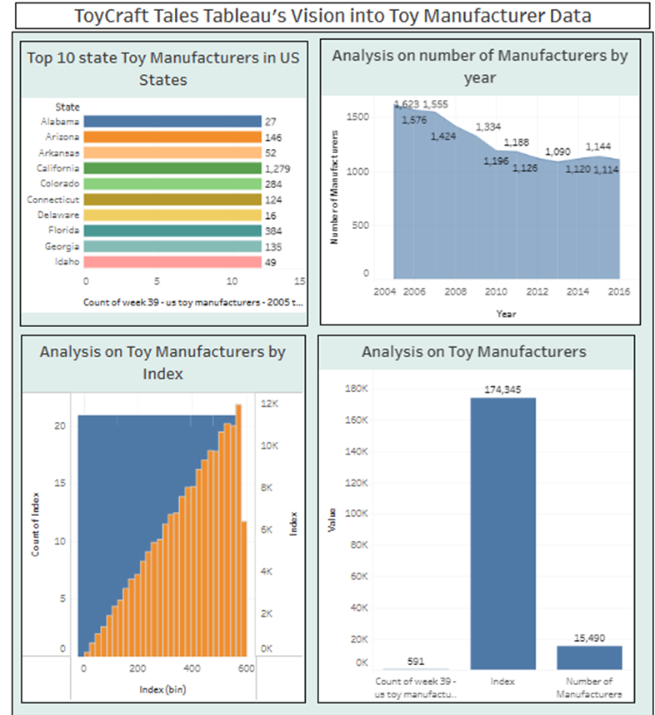

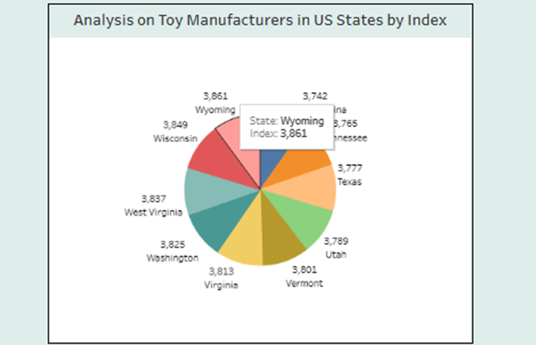

**Dashboard**

A dashboard is a graphical user interface (GUI) that displays information and data in an organized, easy-to-read format. Dashboards are often used to provide real-time monitoring and analysis of data, and are typically designed for a specific purpose or use case. Dashboards can be used in a variety of settings, such as business, finance, manufacturing, healthcare, and many other industries. They can be used to track key performance indicators (KPIs), monitor performance metrics, and display data in the form of charts, graphs, and tables.

**Responsive and Design of Dashboard**

The responsiveness and design of a dashboard for analyzing the performance ToyCraft Tales: Tableau's Vision into Toy Manufacturer Data is crucial to ensure that the information is easily understandable and actionable. Key considerations for designing a responsive and effective dashboard include user-centered design, clear and concise information, interactivity, data-driven approach, accessibility, customization, and security. The goal is to create a dashboard that is user-friendly, interactive, and data-driven, providing actionable insights to improve the performance ToyCraft Tales: Tableau's Vision into Toy Manufacturer Data. Once you have created views on different sheets in Tableau, you can pull them into a dashboard.

 Explanation video link: [Link](https://drive.google.com/file/d/1bgFq8C5j_nGRgIePJNhlM3AvA4ldKAs7/view?usp=sharing%20ToyCraft%20Tales%20|%20Tableau%20Public)

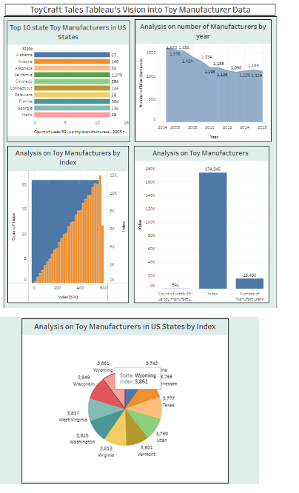

**Story**

A data story is a way of presenting data and analysis in a narrative format, with the goal of making the information more engaging and easier to understand. A data story typically includes a clear introduction that sets the stage and explains the context for the data, a body that presents the data and analysis in a logical and systematic way, and a conclusion that summarizes the key findings and highlights their implications. Data stories can be told using a variety of mediums, such as reports, presentations, interactive visualizations, and videos.

**No of Scenes of Story**

The number of scenes in a storyboard for a data visualization analysis of ToyCraft Tales: Tableau's Vision into Toy Manufacturer Data will depend on the complexity of the analysis and the specific insights that are trying to be conveyed. A storyboard is a visual representation of the data analysis process and it breaks down the analysis into a series of steps or scenes.

 Explanation video link: [Link](https://drive.google.com/file/d/1WgBkbrhREsGtOlUvon2tPml6qWs2DFZq/view?usp=sharing%20ToyCraft%20Tales%20Story%20|%20Tableau%20Public)

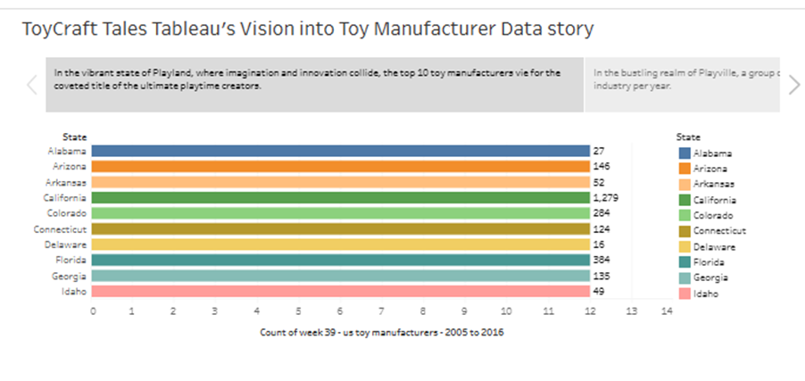

**Performance Testing**

**Amount of Data Rendered to DB**

The amount of data that is rendered to a database depends on the size of the dataset and the capacity of the database to store and retrieve data.

Open the MySQL Workbench, go to the database then click to expand the tables, select the table, and click on the (i) button to get the information related to the table such as column count, table rows etc.

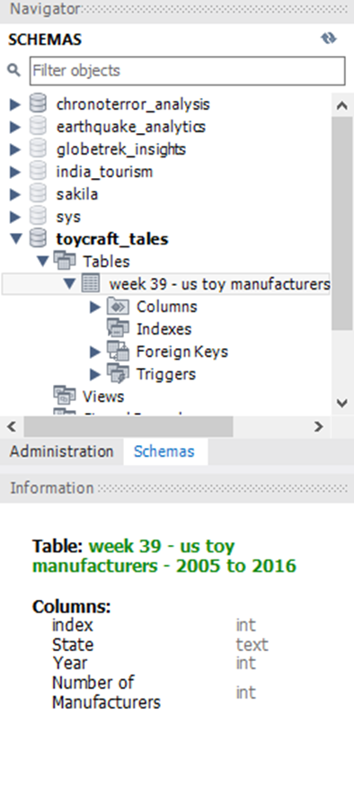

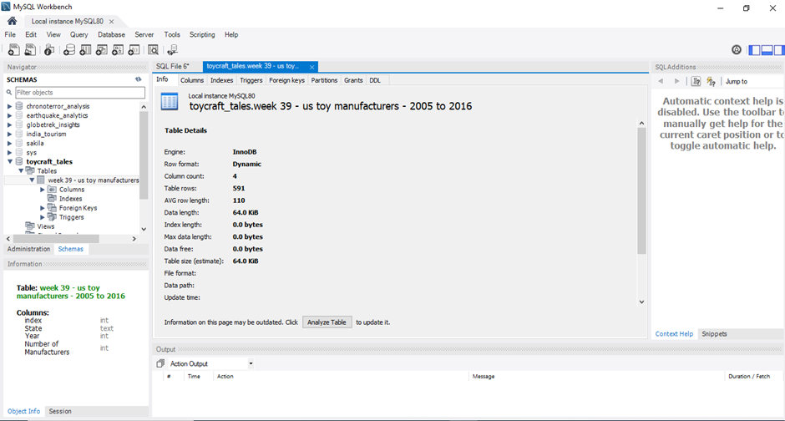

**Utilization of Data Filters**





**No of Calculation Fields**

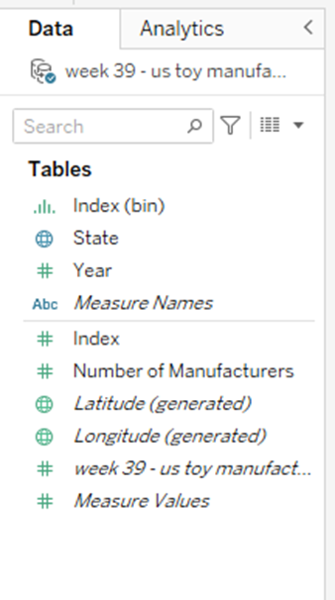

**No of Visualizations/ Graphs**

1. Analysis of the number of Manufacturers by Year
2. Analysis of Toy Manufacturer by Index
3. Analysis of toy Manufacturers in US state By Index
4. Analysis of Toy Manufacturers
5. Top 10 states toy manufacturer in US state

### **Web Integration**

Publishing helps us to track and monitor key performance metrics, and to communicate results and progress. help a publisher stay informed, make better decisions, and communicate their performance to others.

Publishing dashboard and reports to tableau public

 Step 1: Go to Dashboard/story, click on the share button on the top ribbon

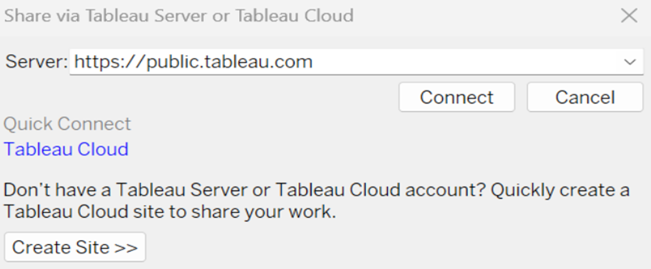

Give the server address of your Tableau public account and click on connect.

Explanation Video:-

[Link](https://drive.google.com/file/d/1ASaZQCNoCcexyKjrg_4HlJlSgrWXNFjw/view?usp=sharing)

Step 2:  Once you click on connect it will ask you for Tableau public user name and password

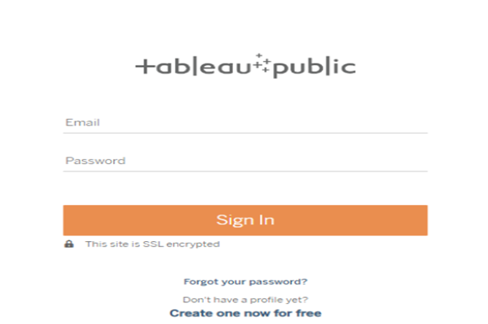

Once you log into your Tableau Public using the credentials, the particular visualization will be published into Tableau Public Note: While publishing the visualization to the public, the respective sheet will get published when you click on the share option.

**Web Integration**

Publishing helps us to track and monitor key performance metrics, and to communicate results and progress. help a publisher stay informed, make better decisions, and communicate their performance to others.

Publishing dashboard and reports to tableau public

 Step 1: Go to Dashboard/story, click on the share button on the top ribbon



Give the server address of your Tableau public account and click on connect.

Explanation Video:-

[Link](https://drive.google.com/file/d/1ASaZQCNoCcexyKjrg_4HlJlSgrWXNFjw/view?usp=sharing)

Step 2:  Once you click on connect it will ask you for Tableau public user name and password



Once you log into your Tableau Public using the credentials, the particular visualization will be published into Tableau Public Note: While publishing the visualization to the public, the respective sheet will get published when you click on the share option.

**Dashboard and Story embed with UI With Flask**

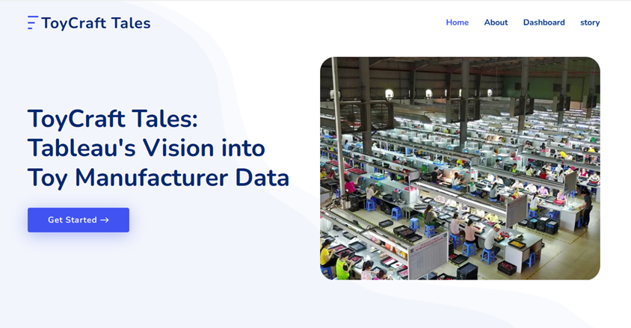

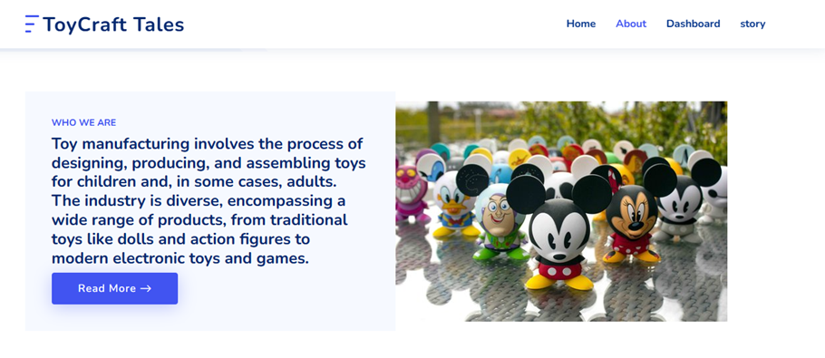

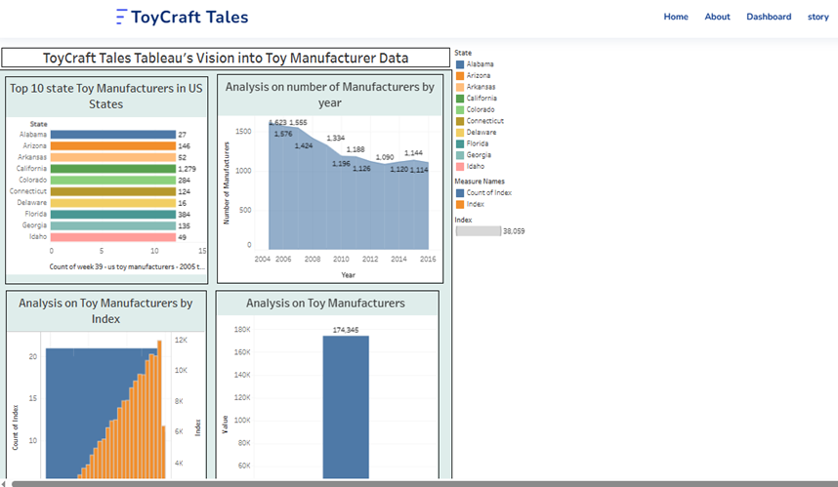

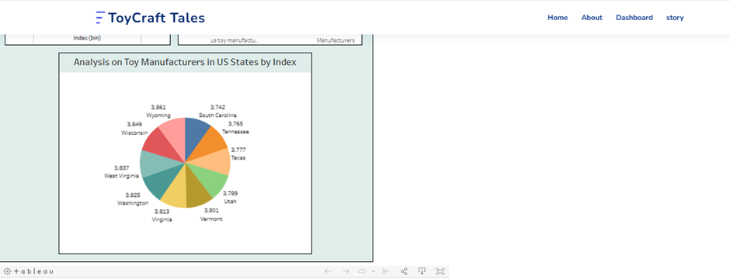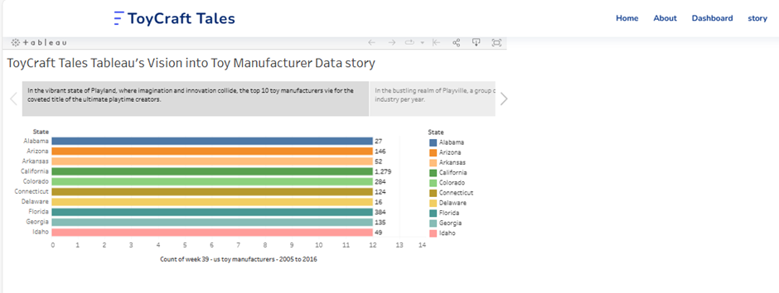

**Project Demonstration & Documentation**

Below mentioned deliverables are to be submitted along with other deliverables

Activity 1:- Record an explanation Video for the project end to end solution

Activity 2:- Project Documentation-Step by step project development procedure

Create a document as per the template provided